NGCX – 64146
Pre-pop-e-api
Add new ATR fields to planning areas – Aptus SL
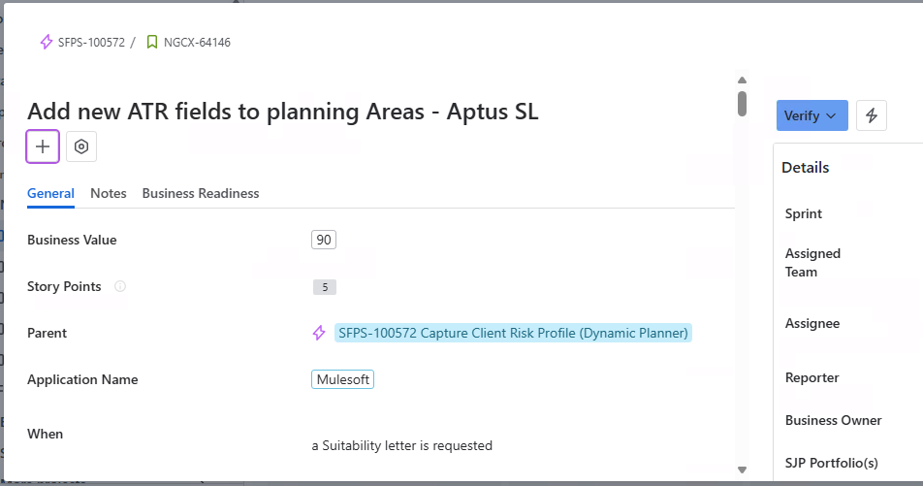
Team Co-ordinated:
- Lead = Prajakta, Vignesh, Isabel.
- Colleague = Raj Prabin, Mahesh Padmala.
Mapping Sheet request access was not worked.
After task assigning up to 3-4 days, I didn’t got the Mapping sheet.
Meanwhile worked under Prajaktas direction, analyzed the flow.
1 – day after I found where to add/map the fields in the coding part.
Raj-Prabin:
1 day after got the JSON file which contains the object with fields and its values to map.
Then in code we should map equally to client.Id == Id.
Logic help was given by prajakta.
DEV & SIT Details:
After Mappings, the dev environment & SIT Env details are get from Raj.
With the JSON file development was completed, and commit to Bit Bucket.
MUnit:
In MUnit part, modified the connectors to cover new code which is recently added.
Using SIT Environment Encryption key, checked we are getting the expected output in the xml format.
Results came as we expected for both Primary & Secondary account.
All MUnit connectors and codes are tested and covered about 100.00% code coverage.
Then again commit to bit bucket.
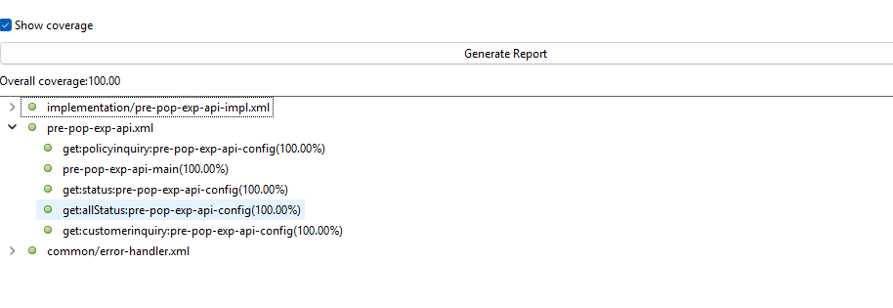

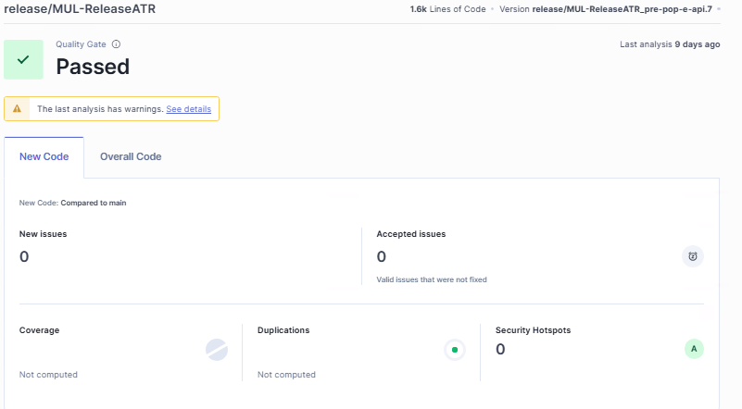

Build Pipeline:
Everytime when we commit in bit-bucket, it starts automatic pipeline deploy.
Prepare Build Unit Test SonarQube Quality Gate End.
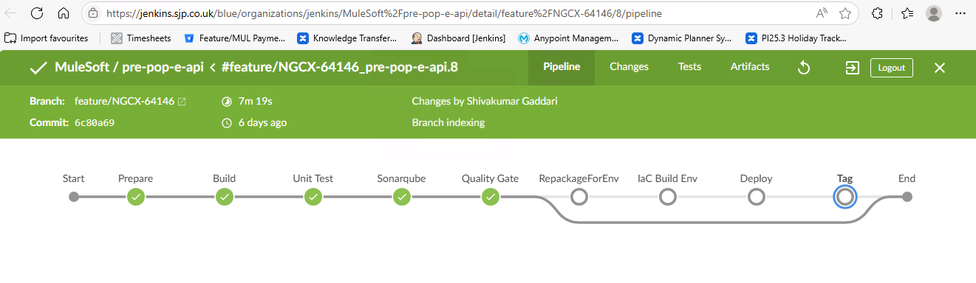

PR Request:
After the pipeline was successful, Raised PR- pull request to lead and Vignesh after verifying & approved then Merge with MUL-release/ATR.
After Merging in Jenkins, we have to build with Dev Env Details.
It once again start to build in Jenkins with dev Env. After Deployment was successful in Jenkins we have to get the tag.
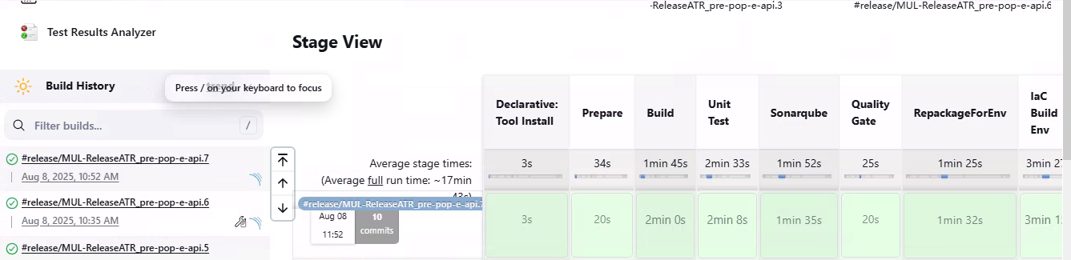
SIT Deployment:
After Jenkins dev deployment, we have to raise ERM(Environment Request Management) team (SIT Team).
They will deploy with SIT Environment.
Then it moves to Round 1 Test Execution.
Add Screenshots of MUnit coverage, TDD Documentation, SonarQube metrics, Updated Connected Versions, under each sub tasks.
Whole Process:
